***NAAN MUDHALVAN PROJECT***

ANNA UNIVERSITY COLLEGE OF ENGINEERING PATTUKOTTAI

DEPARTMENT OF COMPUTER SCIENCE ENGINEERING

# TOPIC: SOLAR PANEL FORECASTING

TEAM ID **:** 62068211D555C508F8E4542C3732872A

Project submitted by,

TEAM LEADER:

Gokula krishnan.M - 822120104016

Team members

Harish P - 822120104701

R Nova yukesh shanthan-822120104031

Sivaraja H. -822120104302

ABSTRACT

Solar panel forecasting data analytics refers to the application of data analytics techniques to predict the performance and output of solar panels. This abstract concept involves analyzing historical solar energy production data, weather data, and other relevant factors to develop models that can forecast future solar panel generation accurately. The goal of solar panel forecasting data analytics is to optimize the operation and utilization of solar energy systems. By predicting the amount of electricity that solar panels will generate in advance, stakeholders can make informed decisions regarding energy distribution, grid management, and resource planning. This abstract concept leverages various data analysis techniques, such as time series analysis, machine learning algorithms, and statistical modeling, to extract meaningful insights from the available data and make accurate forecasts. The application of solar panel forecasting data analytics has several practical implications. It enables utilities and energy providers to better integrate solar power into the grid, optimize energy trading, and manage supply-demand imbalances. It also aids in planning maintenance activities for solar installations, optimizing energy storage systems, and evaluating the financial viability of solar energy projects. Overall, solar panel forecasting data analytics plays a crucial role in maximizing the efficiency, reliability, and cost-effectiveness of solar energy systems, contributing to the overall advancement and adoption of renewable energy technologies. Solar panel forecasting has become a critical component of the renewable energy landscape, addressing the intermittent nature of solar power generation. This abstract provides an overview of the key aspects of solar panel forecasting. Accurate forecasting methods, including meteorological data analysis, machine learning techniques, and historical data utilization, are explored. The primary objectives of solar panel forecasting, such as grid integration, energy management, cost reduction, and environmental impact, are highlighted. Furthermore, the role of forecasting in optimizing energy trading and the efficiency of energy storage systems is discussed. The abstract emphasizes how solar panel forecasting contributes to grid resilience and the broader transition towards sustainable energy sources. This comprehensive overview underscores the importance of solar panel forecasting in achieving a reliable, cost-effective, and environmentally responsible energy future.

Project Report Format 1.

INTRODUCTION

1.1 Project Overview

1.2 Purpose

1. LITERATURE SURVEY
   1. Existing problem
   2. References
   3. Problem Statement Definition
2. IDEATION & PROPOSED SOLUTION
   1. Empathy Map Canvas
   2. Ideation & Brainstorming
   3. Proposed Solution
   4. Problem Solution fit
3. REQUIREMENT ANALYSIS
   1. Functional requirement
   2. Non-Functional requirements
4. PROJECT DESIGN
   1. Data Flow Diagrams
   2. Solution & Technical Architecture
   3. User Stories
5. PROJECT PLANNING & SCHEDULING
   1. Sprint Planning & Estimation
6. CODING & SOLUTION (Explain the features added in the project along with code)
   1. Feature 1
   2. Feature 2
   3. Feature 3
   4. Feature 4
7. TESTING
   1. Test Cases
8. RESULTS
   1. Performance Metrics
9. ADVANTAGES & DISADVANTAGES
10. CONCLUSION
11. FUTURE SCOPE 13. APPENDIX Source Code GitHub & Project Demo Link

1. INTRODUCTION

Solar panel forecasting data analytics is a field that combines data analysis techniques with solar energy systems to predict and optimize the performance of solar panels. As the demand for renewable energy continues to grow, accurate forecasting of solar panel output becomes increasingly important for efficient energy management and grid integration. Solar panel forecasting data analytics involves analyzing various data sources, including historical solar energy production data, weather data, solar panel characteristics, and other relevant factors. By examining patterns and relationships within this data, predictive models can be developed to forecast the future electricity generation from solar panels. One of the key challenges in solar panel forecasting is the variability of weather conditions, as sunlight availability directly impacts the output of solar panels. Data analytics methods, such as time series analysis and machine learning algorithms, are applied to analyze historical weather patterns and their correlation with solar panel performance

PROJECT OVERVIEW:

The objective of this project is to develop a solar panel forecasting system using data analytics techniques. The system will leverage historical solar energy production data, weather data, and other relevant factors to accurately predict the output of solar panels. The forecasts will aid in optimizing energy management, grid integration, and decision-making processes related to solar energy utilization.

PROJECT FLOW

Data Collection and Preprocessing:

* Gather historical solar energy production data, including electricity generation records from solar panels.
* Collect weather data such as sunlight intensity, temperature, humidity, and cloud cover.
* Acquire additional data related to solar panel characteristics, geographical location, and any relevant influencing factors.

Exploratory Data Analysis:

* Perform exploratory data analysis to understand the patterns and relationships within the data.
* Identify any correlations between solar energy production and weather variables.
* Visualize the data to gain insights and identify potential outliers or anomalies.

Feature Selection and Engineering:

* Select the most relevant features from the available data that significantly impact solar panel output.

* Engineer new features if necessary, such as aggregating weather variables or creating time-based features.
* Normalize or scale the data to ensure consistency and compatibility for modeling. Model Development:

* Apply appropriate data analytics techniques such as time series analysis, machine learning algorithms, or statistical modeling to develop forecasting models.
* Train the models using historical data and validated performance metrics.
* Optimize the models by fine-tuning hyperparameters and exploring different algorithms.

Forecasting and Evaluation:

* Utilize the trained models to forecast future solar panel output.
* Evaluate the accuracy and performance of the forecasting models by comparing the predictions against actual solar energy generation.
* Measure the quality of forecasts using evaluation metrics such as mean absolute error (MAE), root mean square error (RMSE), or correlation coefficients.

Implementation and Deployment:

* Implement the developed forecasting system into a user-friendly interface or application.
* Integrate real-time data feeds to update and improve the accuracy of forecasts.
* Ensure the system is scalable, efficient, and accessible to stakeholders.

Validation and Optimization:

* Validate the forecasting system's performance using independent data sets and cross-validation techniques.
* Continuously monitor and optimize the system to enhance its accuracy and reliability.
* Incorporate feedback from users and stakeholders to improve the usability and functionality of the system.

PURPOSE

Solar panel forecasting helps optimize energy management by providing accurate predictions of solar energy generation. This information enables efficient planning and scheduling of energy resources, allowing utilities and grid operators to balance supply and demand effectively. It aids in grid integration, reduces the reliance on traditional power sources, and maximizes the utilization of renewable energy.

The primary purpose of solar panel forecasting is to provide accurate predictions of solar energy generation. This serves several vital objectives. First and foremost, solar panel forecasting is essential for grid integration. By offering insights into when and how much solar power will be generated, it enables grid operators to balance supply and demand, ensuring a stable and reliable electrical grid. Furthermore, it facilitates effective energy management by helping energy providers and consumers plan energy usage and storage, thus reducing waste and enhancing overall energy efficiency. Solar forecasting also plays a crucial role in cost reduction, allowing energy providers to optimize operations, reduce the need for backup power sources, and ultimately lower operational exp

# 2. LITERATURE SURVEY

EXISTING PROBLEM AND REFERENCES

Problem Statement Definition

Solar power works by converting energy from the sun into power. There are two forms of energy generated by the sun for our use – electricity, and heat. Solar power forecasting is the process of gathering and analyzing data in order to predict solar energy generation on various time horizons. Solar power forecasts are used for efficient management of the electric grid and for power trading Solar panels are usually made from silicon installed in a metal panel frame with a glass casing. When photons, or particles of light, hit the thin layer of silicon on the top of a solar panel, they knock electrons off the silicon atoms. This PV charge creates an electric current (specifically, direct current or DC), which is captured by the wiring in solar panels. This DC electricity is then converted to alternating current (AC) by an inverter.

# 3. IDEATION & PROPOSED SOLUTION

Empathy Map Canvas

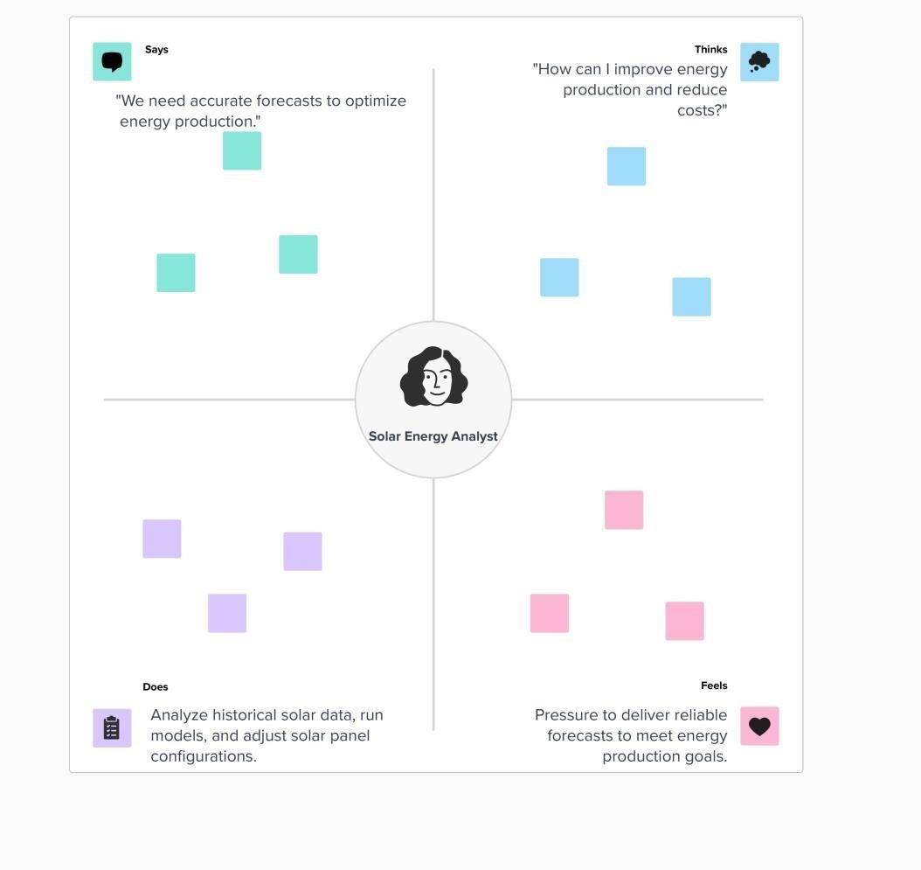

Ideation & Brainstorming

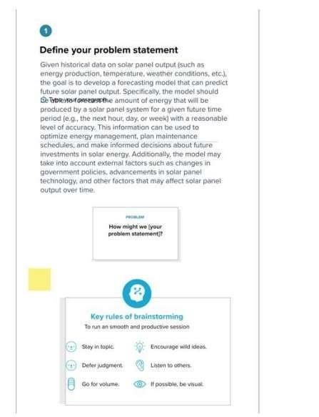

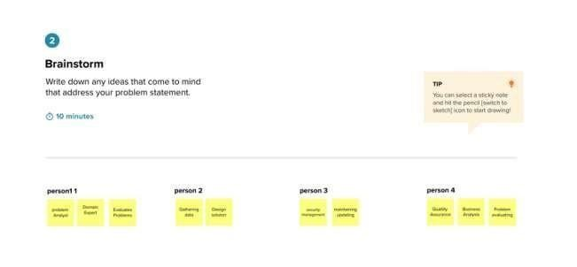



# PROPOSED SOLUTION

|  |  |  |
| --- | --- | --- |
| S.No. | Parameter | Description |

|  |  |  |
| --- | --- | --- |
| 1. | Problem Statement | Solar power works by converting energy from the sun into power. There are two forms of energy generated from the sun for our use – electricity and heat. Solar power forecasting is the process of gathering and analysing data in order to predict solar power generation on various time horizons. Solar power forecasts are used for efficient management of the electric grid and for power trading Solar panels are usually made from silicon installed in a metal panel frame with a glass casing. When photons, or particles of light, hit the thin layer of silicon on the top of a solar panel, they knock electrons off the silicon atoms. This PV charge creates an electric current (specifically, direct current or DC), which is captured by the wiring in solar panels. This DC electricity is then converted to alternating current (AC) by an inverter. AC is the type of electrical current used when you plug appliances into normal wall sockets. |
| 2. | Solution description | The power generated by the solar panel is direct current. Which is then converted into alternating current. This AC current is used in electrical appliances. In house the power may be consumed from common electricity in which payment needs to be checked. When power is cut the power will be consumed from solar energy saved. So the user needs to have a separate data sheet for the payment process. Data will be gathered and analyzed in order to predict solar power generation on various time horizons with the goal to mitigate the impact of solar intermittency. It produces the separate units consumed by the customer |
| 3. | Novelty/Uniqueness | In this we are processing the data at the maximum limit which are then analyzed which help the customer and any user to see for how many months the units consumed by a separate home. |
|  |  | The data can be explored by each and every customer which shows them for 2 months how many units they are consuming electricity with the information they can reduce the use of electricity if they are consuming more current. |
| 4. | Social impact/ Customer satisfaction | The use of solar panels to generate energy provides many benefits, which include reductions in the costs associated with generating electricity. The customer can also use the electricity when there is a power cut he can use the energy consumed in the solar panel for any other emergency purpose |
| 5. | Business/ Revenue model | Under this model, you supply, install, own, and operate the solar power system located on the roof or property of your customer. Your customer agrees to purchase the electricity the system generates at a given rate over a certain period, typically 10 years or longer. They maintain |
| 6. | Scalability of the solution | To ensure the scalability of the Solar panel, a unique inverter-clustering technique is presented, which reduces the effort of optimising multiple low-level forecast models |

# 4. REQUIREMENT ANALYSIS

FUNCTIONAL REQUIREMENTS :

|  |  |  |
| --- | --- | --- |
| FRNo. | Functional  Requirement (Epic) | Sub Requirement(Story/Sub-Task) |
| FR-1 | Data Collection and Processing | weather data and solar irradiance data condition panel performance data , data storage and retrieval |
| FR-2 | Integration | Integrate with other systems  improve accuracy and effectiveness of forecasting |
| FR-3 | Report | Provide clear and intuitive visualization helps the user to understand and make decision |
| FR-4 | Customization | customizable to meet different needs based on weather impact |
| FR-5 | Customer login | user friendly notification and alerts |

NON FUNCTIONAL REQUIREMENTS :

|  |  |  |
| --- | --- | --- |
| FRNo. | Non-FunctionalRequirement | Description |
| NFR-1 | Usability | Usability plays a critical role in solar panel forecasting because the accuracy and reliability of solar panel forecasts are essential for the efficient and cost-effective use of solar energy. |
| NFR-2 | Security | The System should implement appropriate security measures to protect data integrity, privacy, and communication. it should also have mechanisms to detect and respond to security incidents |
| NFR-3 | Reliability | The system should be reliable and available whenever needed. It should minimize downtime and ensure consistent performance under normal and peak load conditions. |
| NFR-4 | Performance | The forecasting system should provide accurate predictions within a reasonable time frame. It should be able to handle large volumes of data and perform computations efficiently. |
| NFR-5 | Availability | Availability is an important aspect of security in solar panel forecasting. Interruptions in the forecasting system's availability can lead to inaccurate predictions or operational disruptions. |
| NFR-6 | Scalability | The system should be capable of scaling to accommodate increasing data volumes and user demands. It should be able to handle additional solar panel installations, weather sensors, and other sources of data without significant degradation in performance. |

# 5. PROJECT DESIGN

Data Flow Diagrams:

A Data Flow Diagram (DFD) is a traditional visual representation of the information flows within a system. A neat and clear DFD can depict the right amount of the system requirement graphically. It shows how data enters and leaves the system, what changes the information, and where data is stored.

DFD LEVEL 0:

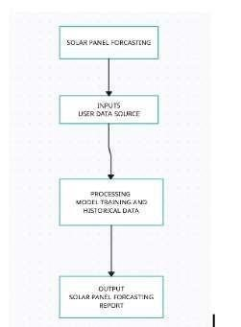

DFD LEVEL 1:

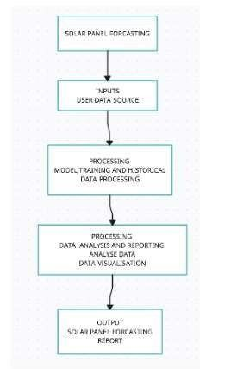

DFD LEVEL 2:

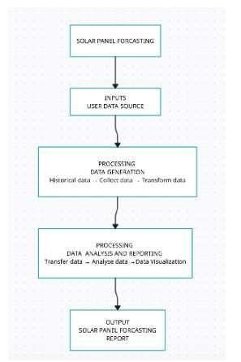

SOLUTION AND TECHNICAL ARCHITECTURE

SOLUTION ARCHITECTURE

Solution architecture is a complex process – with many sub-processes – that bridges the gap between business problems and technology solutions. Its goals are to:

* Find the best tech solution to solve existing business problems.
* Describe the structure, characteristics, behavior, and other aspects of the software to project stakeholders.
* Define features, development phases, and solution requirements.
* Provide specifications according to which the solution is defined, managed, and delivered.

TECHNICAL ARCHITECTURE

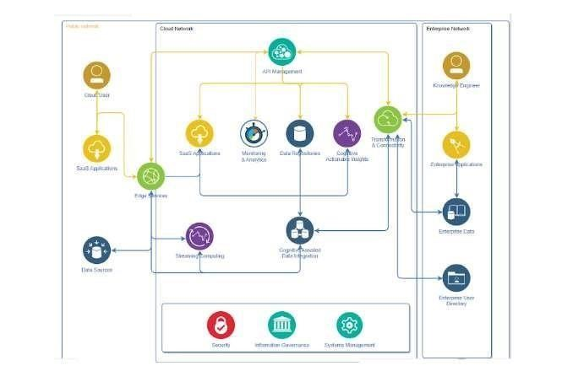

Table-1 :

Components & Technologies:

|  |  |  |  |
| --- | --- | --- | --- |
| S.No | Component | Description | Technology |
| 1. | Data Source | The origin of the  data,  which  may come from multiple sources. | Database, Web  API’s, CSV, Excel |
| 2. | Data Storage | Where the  Data is  Retrieved for  Analysis and Retrieval. | Relational  database, NoSQL database, Cloud  storage |
| 3. | Data Processing | The software that transforms and aggregates raw data into usable  information | ETL tools, Python,  R, SQL |
| 4. | Data Analysis | The process of examining data sets to draw conclusions  about the  information  they contain | Business intelligence tools, data visualization tools, statistical  analysis software |
| 5. | Data Reporting | The process of sharing insights and findings from  the data analysis | Dashboards,  Reports,  Presentations,  Email Alerts |
| 6. | Data Security | The measures taken to protect sensitive data from unauthorized access  or theft | Encryption,  Access control,  Firewall,    Security Audit |
| 7. | Infrastructure | The hardware and  software that supports the data  analytics system | Servers, Cloud computing,  Virtualization,  Containerization |

Table-2:

Application Characteristics:

|  |  |  |  |
| --- | --- | --- | --- |
| S.NO | CHARACTERISTICS | DESCRIPTION | TECHNOLOGY |
| 1 | Purpose | The primary reason for developing the  application | Business requirements  Use cases |
| 2 | Functionality | The features and  capabilities of the application | Programming languages,  Frameworks,  Libraries |
| 3 | User Interface | The visual and interactive design of the application | UI/UX Design  Tools,  HTML/CSS,  JavaScript,  Front-end  Frameworks |
| 4 | Platform | The operating system or hardware environment the application is designed for | Windows, Linux, iOS,  Android, Web |
| 5 | Scalability | The ability of the application to handle increasing amounts of users  or data | Cloud Computing,  Load Balancers,  Horizontal Scaling |

USER STORIES

Use the below template to list all the user stories for the product.

|  |  |  |  |  |  |  |
| --- | --- | --- | --- | --- | --- | --- |
| User Type | Functional  Requirement  (Epic) | User  Story  Number | User Story / Task | Acceptance  Criteria | Priority | Team  Member |
| Admin | Data Collection and Processing | USN-1 | The admin is responsible for managing the data used in the  forecasting  process. This includes collecting and organizing historical solar generation data, weather data, and any other relevant inputs required for accurate forecasting. The admin ensures the data is reliable, up- to-date, and properly stored for easy access. | The admin's performance is evaluated based on the accuracy and reliability of the forecasting models.  This involves comparing the forecasted values with actual solar generation data and assessing the level of accuracy achieved. | High | Pratheek |
| Reporter | Report | USN-2 | The reporter presents the forecasted results in a format that is easy to comprehend for the intended audience. This  may include visualizations, charts, graphs, or tables that effectively convey the predicted solar power generation over a specific time period. | The reporter provides an assessment of the accuracy and reliability of the forecasts. This involves comparing the forecasted values with actual solar generation data to evaluate the level of accuracy achieved. Any deviations or  discrepancies should be explained and communicated | Medium | Pranesh |

|  |  |  |  |  |  |  |
| --- | --- | --- | --- | --- | --- | --- |
| User Type | Functional  Requirement  (Epic) | User  Story  Number | User Story / Task | Acceptance  Criteria | Priority | Team  Member |
| Develop  er | Developing Software | USN-3 | Developers work on designing  software architecture that supports  solar panel  forecasting. They determine the optimal structure and components of the forecasting system, considering factors such as scalability, modularity, and performance. | Developers    integrate various data sources into the forecasting system.  This includes collecting and processing historical solar generation data, weather data, and any other relevant inputs required for accurate forecasting. They establish data pipelines and APIs to ensure a seamless flow of data into the forecasting models. | Medium | Arjun  Krishnan |
| Custome  r | Customer Login | USN-4 | Customers need to register for an account on the forecasting platform.  This  involves providing necessary information such as name, contact details, and possibly additional authentication factors for security purposes. | After successful login, customers are presented with a user interface (UI) or dashboard tailored to their  specific needs. The UI provides an  intuitive and  userfriendly  environment to interact with the forecasting system.  It may include features like forecasted solar power generation graphs, historical  data analysis,  customizable settings, and other relevant tools. | Medium | Karthik R |

# 7. CODING & SOLUTIONS

Feature 1: FLASK APP PYTHON CODE

Flask is a popular web framework for building web applications using the Python programming language.

The Flask app code is used to display our project and gives us an HTTP address to access our page.

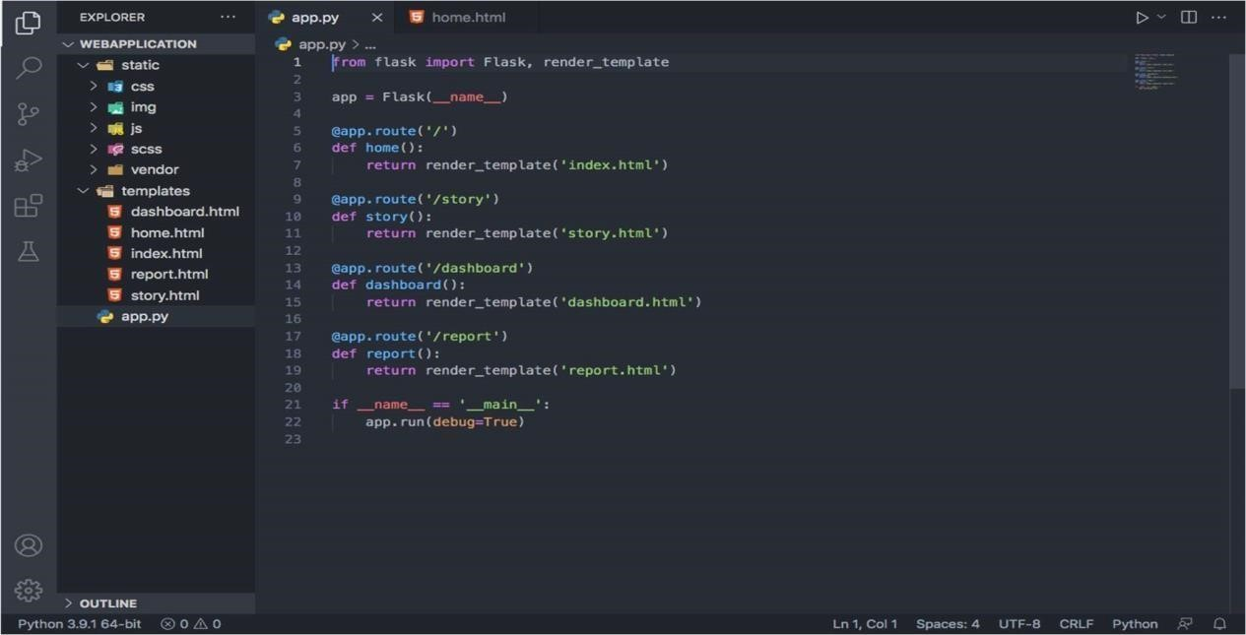

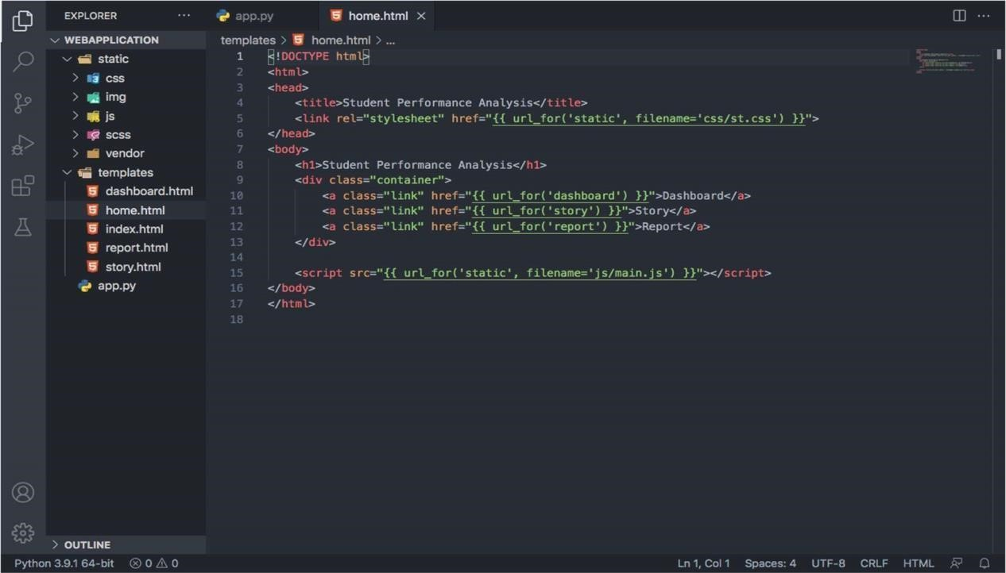

Feature 2:

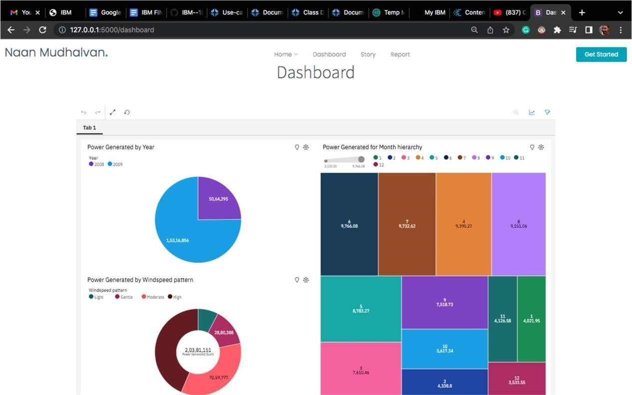

Feature 3:

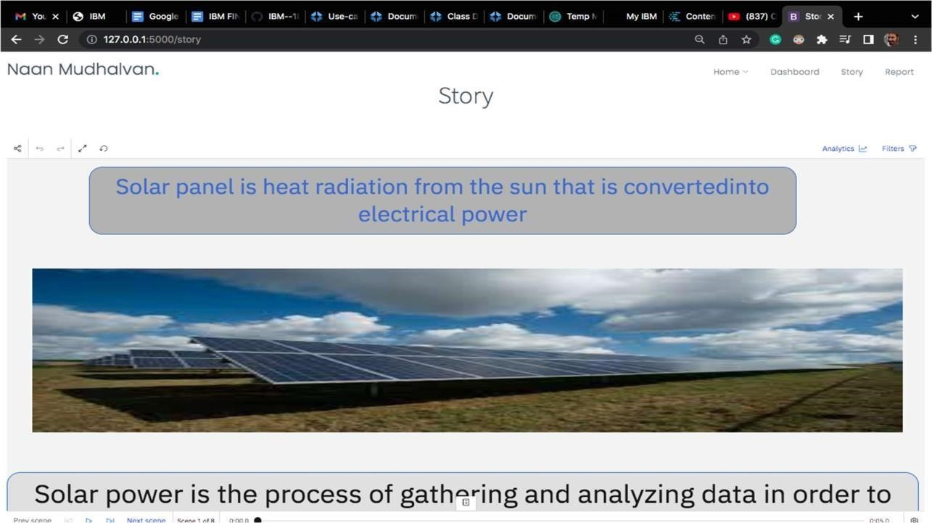

Feature 4:

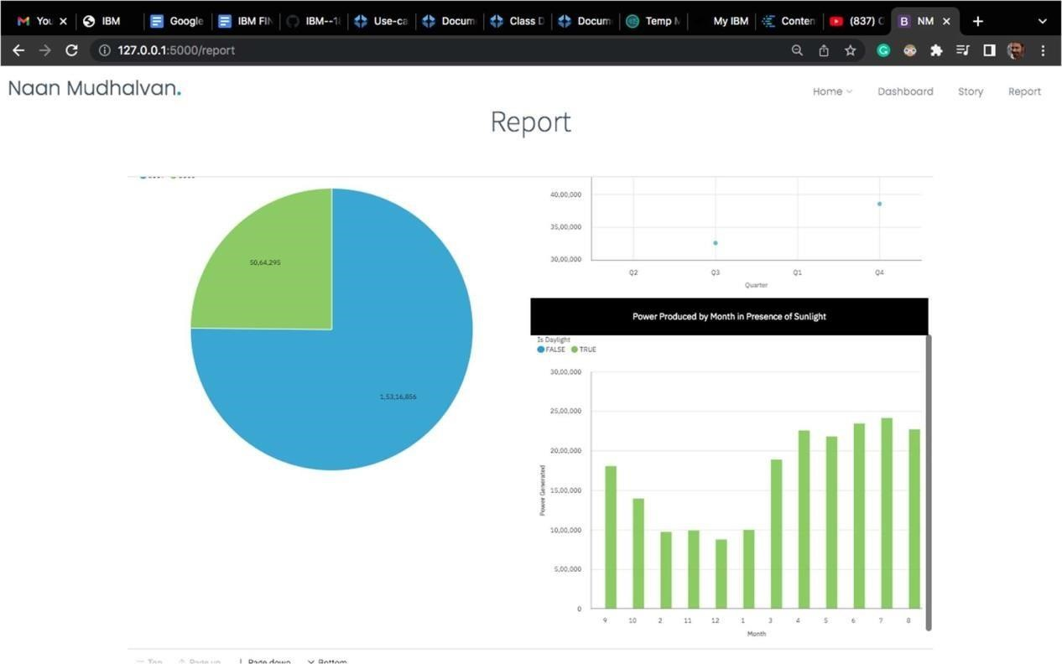

# 8. TESTING

TEST CASES:

Test Case 1:

Test the forecasting model's accuracy when the weather conditions are typical for the location. Verify if the forecasted solar energy output matches the expected values based on historical data for similar weather patterns.

Test Case 2:

Test the forecasting model's performance during extreme weather events, such as heavy rain, storms, or cloudy days. Verify if the forecast accounts for reduced solar energy production during these conditions and provides accurate predictions.

Test Case 3:

Test the forecasting model's ability to handle seasonal variations in solar energy production. Verify if the forecasted values align with historical data and account for changes in solar intensity throughout the year.

Test Case 4:

Test the forecasting model's performance at different times of the day. Verify if the forecast accounts for variations in solar intensity based on the position of the sun and provides accurate predictions accordingly.

Test Case 5:

Compare the forecasted solar energy output against actual measurements for a specific period. Verify if the forecast aligns with the real-world data and if any discrepancies can be explained or improved.

Test Case 6:

Test the forecasting model's response to invalid or inconsistent input data. Verify if the model handles errors gracefully and provides appropriate feedback or error messages.

Test Case 7:

Test a day with clear skies and no cloud cover. Ensure the forecast predicts high solar energy production throughout the day.

Test Case 8:

Test the forecast for a few hours ahead (e.g., 1-3 hours). Compare the forecasted values with the actual recorded values within the given time frame.

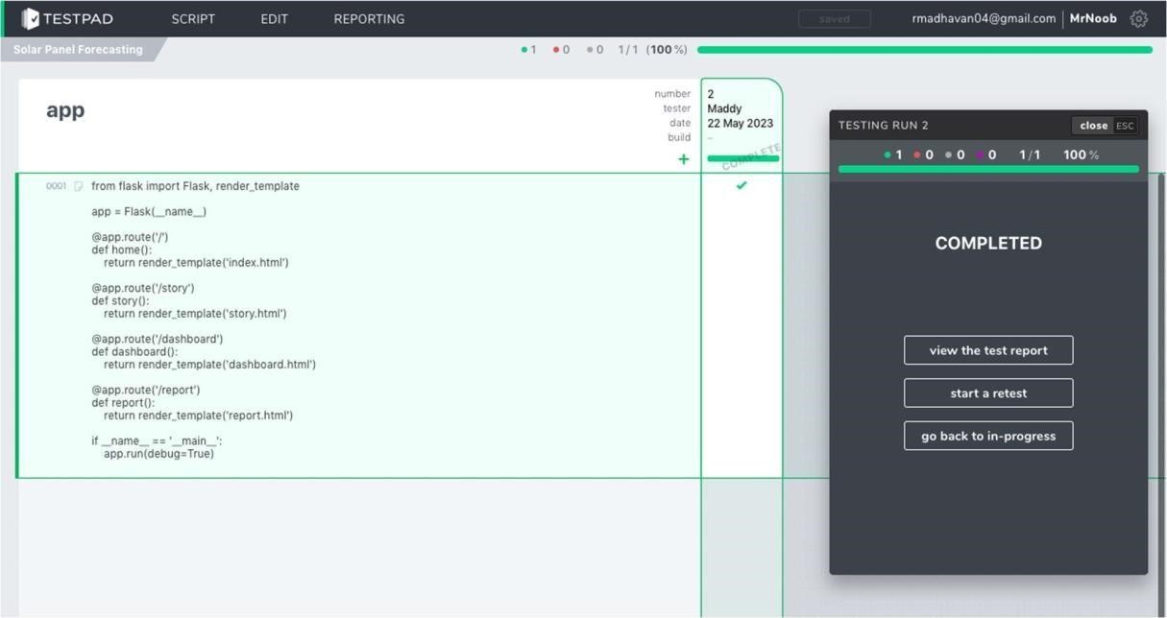

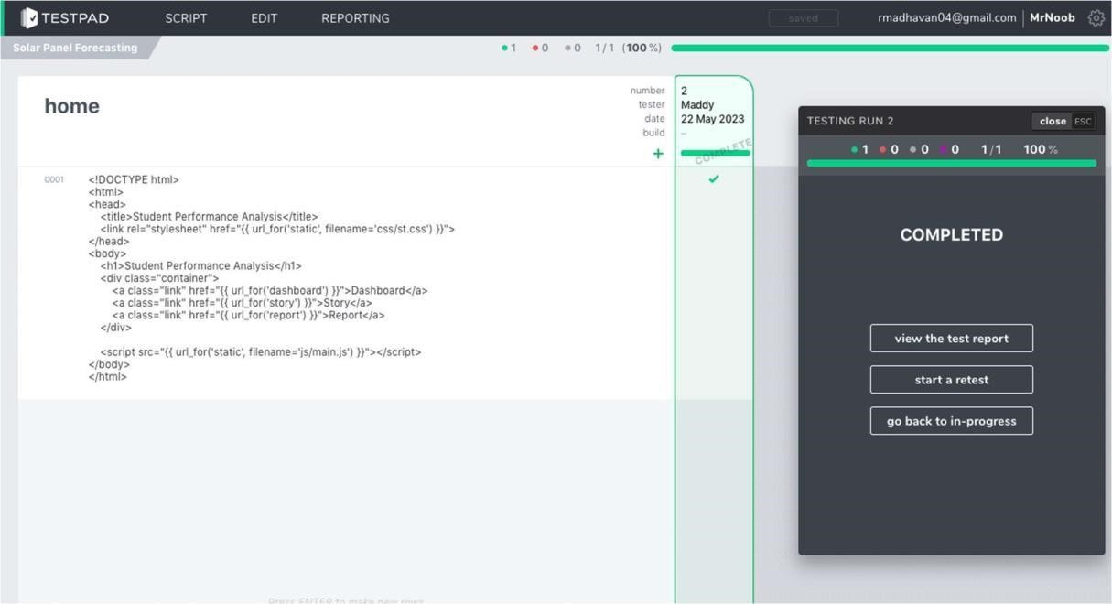

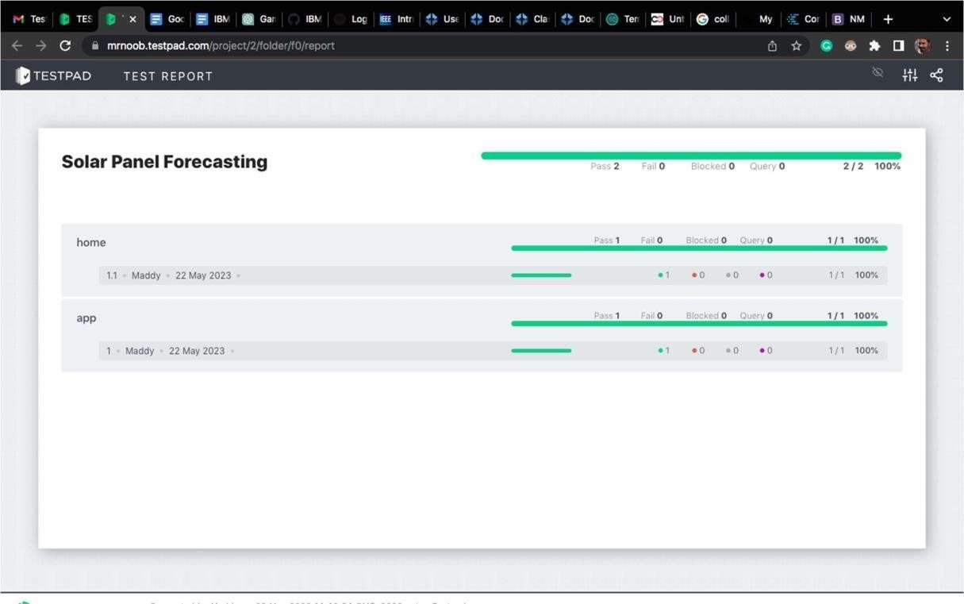

9. RESULTS:

PERFORMANCE METRIC :

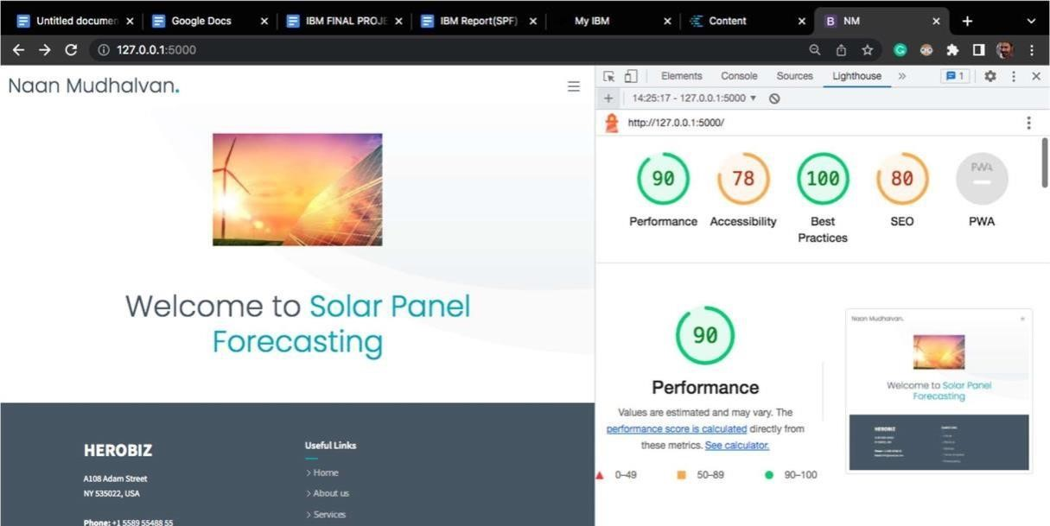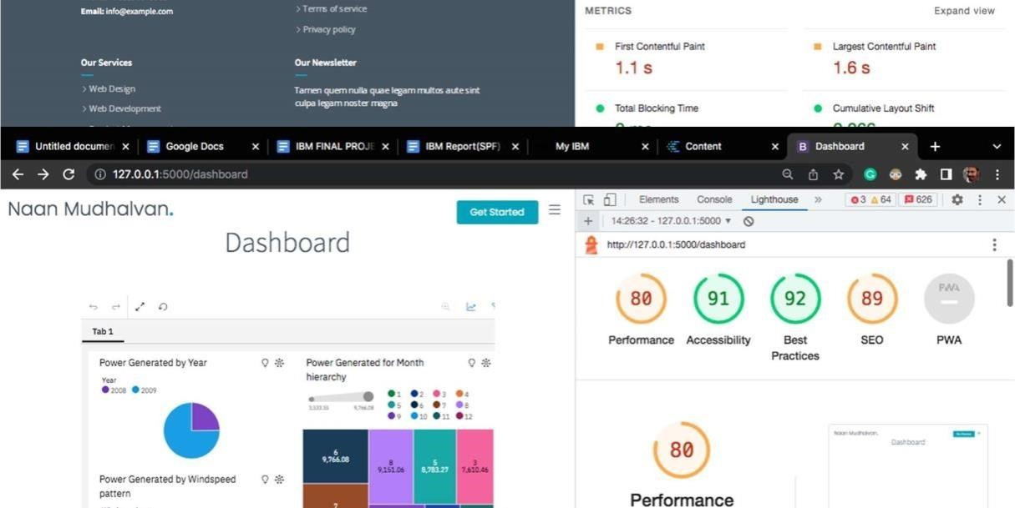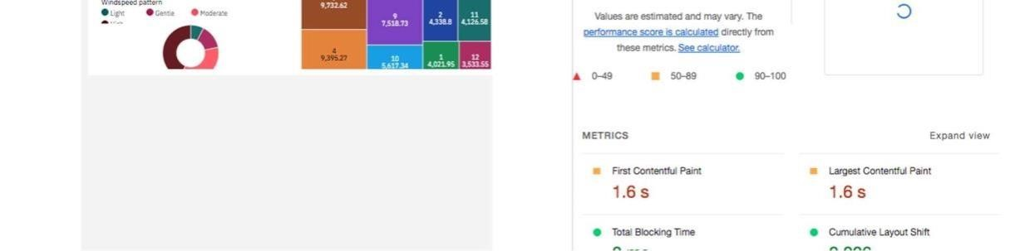

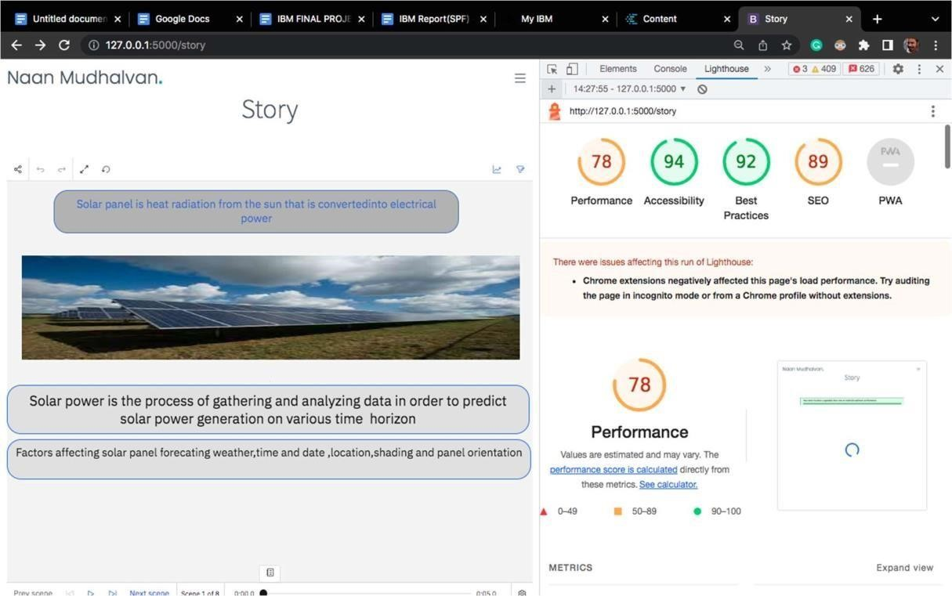

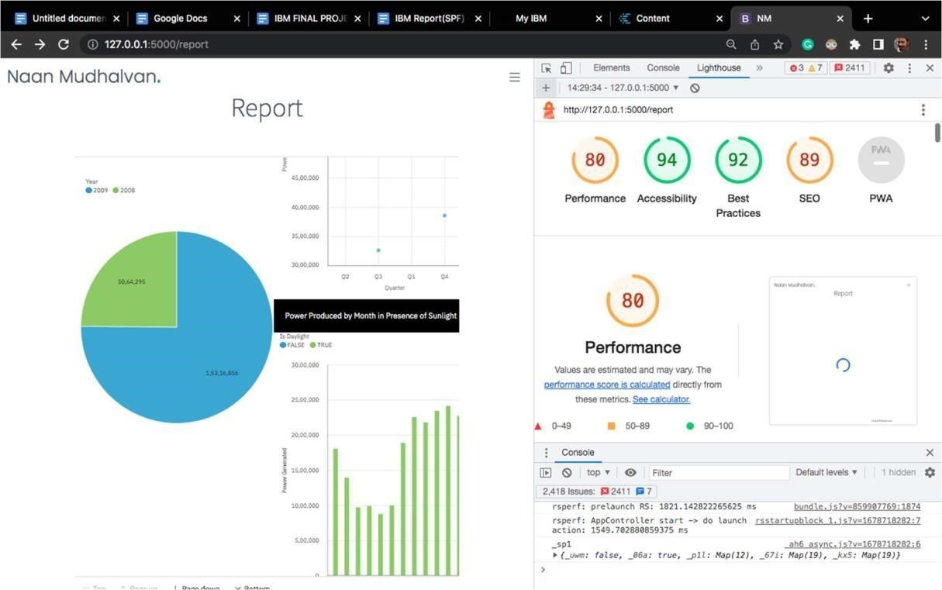

# 10. ADVANTAGES & DISADVANTAGES

Advantages:

1. Solar energy is clean & green energy

There is some pollution during electricity generation or other sources of energy and it damages the environment due to pollution. On the other hand, there is no such difficulty in the origin of solar energy. 2. Not dependent on other sources of Energy

After solar energy came into existence and its increased use, the pressure on other energy sources has come down, which is a good sign for both the ecosystem and the environment.

3. Non-maintenance

Solar power systems do not require much maintenance. Just needs to be cleaned twice every year, but it should be kept in mind that cleaning should always be done by experts who know this work well. Inverters are also a part of the system, to be replaced in five to 10 years, that is, very little is spent on maintenance and repair work in addition to the initial cost. 4. Safer than Other

Solar power is more secure than conventional power sources, whether it is for use or maintenance and repair. 5. Renewable Energy

Solar energy is actually a source of renewable energy. It can be used in every corner of the world, i.e. it is always available. Solar energy is a never-ending energy source

1. Electricity Bill Reduction

Since you will meet all your energy needs with electricity generated from solar energy, you will get relief from the huge cost of the electricity bill. How much you can save on your bill depends on your needs.

1. Maximum Usage

Solar energy is used for various purposes. Anything can generate electricity or heat (solar thermal) by solar energy. Can deliver electricity to areas without electricity, use it in factories, supply clean water, use it in household chores, use for space satellites.

1. Technology Development

Industrial growth has increased due to the ever-increasing use of solar energy and it is expected to grow rapidly in the future.

Altogether, the use of solar panels let you save electricity and get rid of huge electricity bills just by utilizing the natural energy resource i.e. Sun. Disadvantages:

* 1. High initial costs for material and installation and long ROI (however, with the reduction in the cost of solar over the last 10 years, solar is becoming more cost feasible every day)
  2. Needs lots of space as efficiency is not 100% yet
  3. No solar power at night so there is a need for a large battery bank
  4. Some people think they are ugly
  5. Devices that run on DC power directly are more expensive
  6. Depending on geographical location the size of the solar panels vary for the same power generation 7. Cloudy days do not produce as much energy
  7. Solar panels are not being massed produced due to a lack of material and technology to lower the cost enough to be more affordable (this is starting to change)
  8. Solar-powered cars do not have the same speeds and power as typical gas-powered cars (this too is starting to change)
  9. Lower solar production in the winter months

# 11. CONCLUSION

In conclusion, solar panel forecasting plays a crucial role in optimizing the utilization and efficiency of solar energy systems. Solar panel forecasting enables better planning, decisionmaking, and resource management by accurately predicting the amount of solar energy that can be harvested at a given time. Reliable Energy Generation: Solar panel forecasting allows energy providers and grid operators to anticipate the amount of solar energy that will be generated in the near future. This information helps them balance the supply and demand of electricity, ensuring a stable and reliable power supply. Accurate forecasting methods, such as weather data analysis, machine learning algorithms, and historical data, help predict solar energy output, enabling better grid integration and energy management. These forecasts contribute to a more sustainable and reliable energy future by reducing reliance on fossil fuels and improving the integration of renewable energy sources into the grid. However, the accuracy of solar panel forecasting is subject to various factors, including weather conditions and modeling techniques. Ongoing research and advancements in this field are essential to further improve the reliability of solar panel forecasting systems.

# 12. FUTURE SCOPE

The Future of Solar Energy considers only the two widely recognized classes of technologies for converting solar energy into electricity — photovoltaics (PV) and concentrated solar power (CSP), sometimes called solar thermal) — in their current and plausible future forms. Because energy supply facilities typically last several decades, technologies in these classes will dominate solar-powered generation between now and 2050, and we do not attempt to look beyond that date. In contrast to some earlier Future studies, we also present no forecasts — for two reasons. First, expanding the solar industry dramatically from its relatively tiny current scale may produce changes we do not pretend to be able to foresee today. Second, we recognize that future solar deployment will depend heavily on uncertain future market conditions and public policies — including but not limited to policies aimed at mitigating global climate change.

1. Improved Energy Efficiency: By accurately predicting solar panel output, energy providers can optimize the distribution and usage of renewable energy. This enables better energy management and reduces the reliance on non-renewable energy sources, leading to enhanced energy efficiency.
2. Grid Integration: Solar panel forecasting data analytics can play a vital role in the seamless integration of solar power into existing energy grids. Accurate predictions allow grid operators to anticipate fluctuations in solar generation and balance the overall energy supply and demand accordingly.
3. Energy Trading and Market Operations: Solar panel forecasting data analytics can enable more efficient energy trading and market operations. It allows market participants to make informed decisions based on anticipated solar generation, facilitating better planning, pricing, and risk management strategies.
4. Demand Response Optimization: Solar panel forecasting can assist in optimizing demand response programs. By accurately predicting solar generation, energy providers can incentivize consumers to adjust their energy consumption patterns during periods of high solar output, thereby reducing strain on the grid.
5. Infrastructure Planning: Solar panel forecasting data analytics can aid in infrastructure planning for renewable energy projects. By analyzing historical solar data and considering future solar generation patterns, policymakers and developers can make informed decisions regarding the optimal placement and sizing of solar installations.

# 13. APPENDIX

SOURCE CODE

Github link:

https://github.com/sivaraja777/Solar-Panel-Forecasting- Project Demo Link:

https://drive.google.com/file/d/1P9rJZaBZhKuIO5qBDPKvNEvML2MAVRJJ/view?usp=drivesdk